1. Open google play console and sign in with the valid credentials
2. Navigate to the **Setup** → **App Integrity**

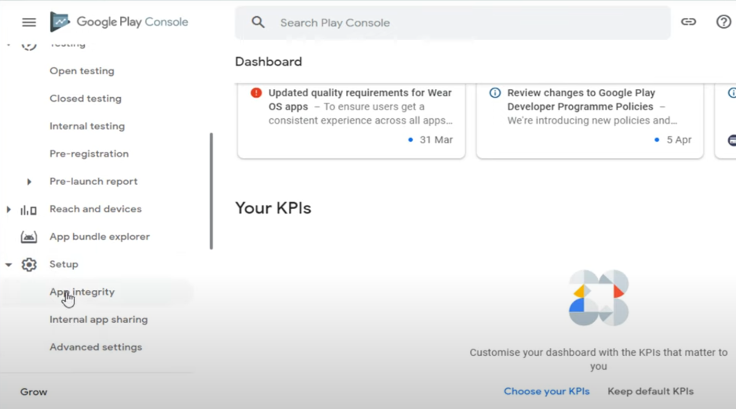

1. Click on the **App Signing** tab.

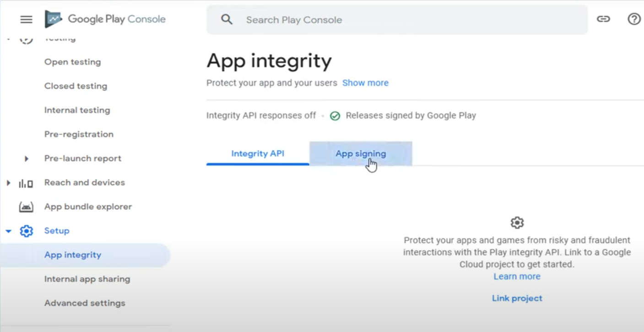

1. Click on the **Request upload key** **reset** button.

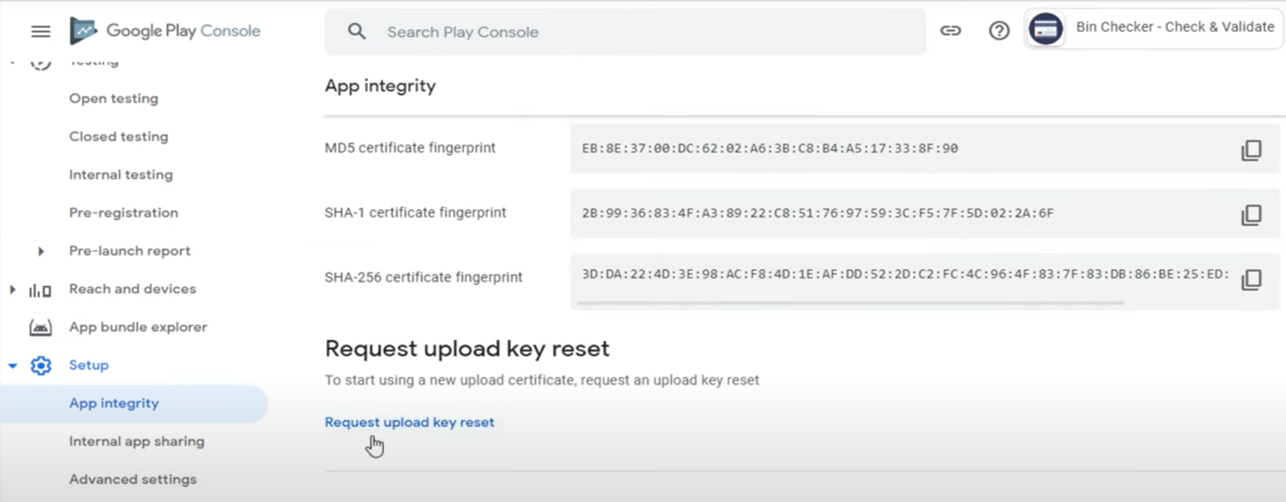

1. Select the valid reason like below.

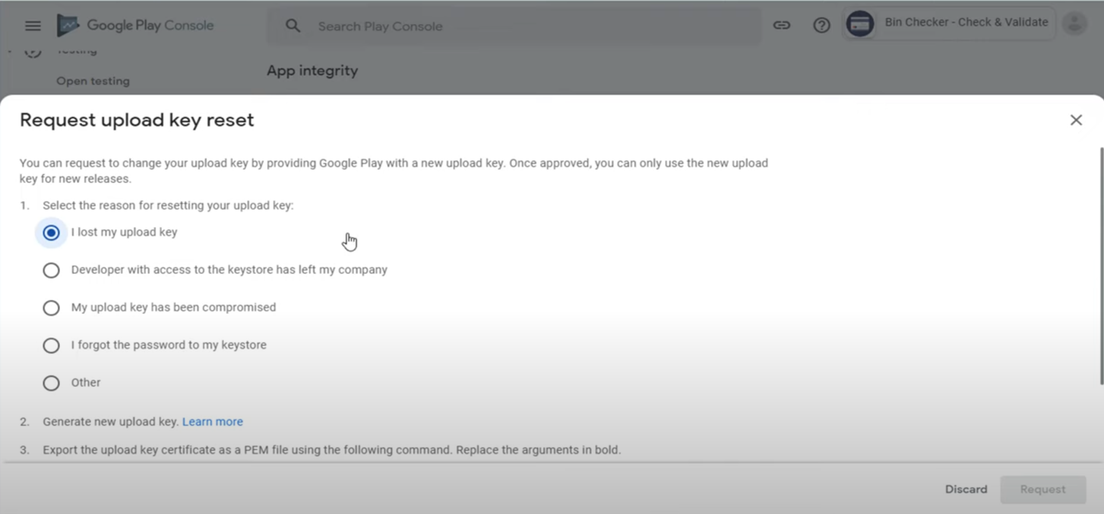

1. Click on the **Upload the .PEM file generated from your upload key certificate.**

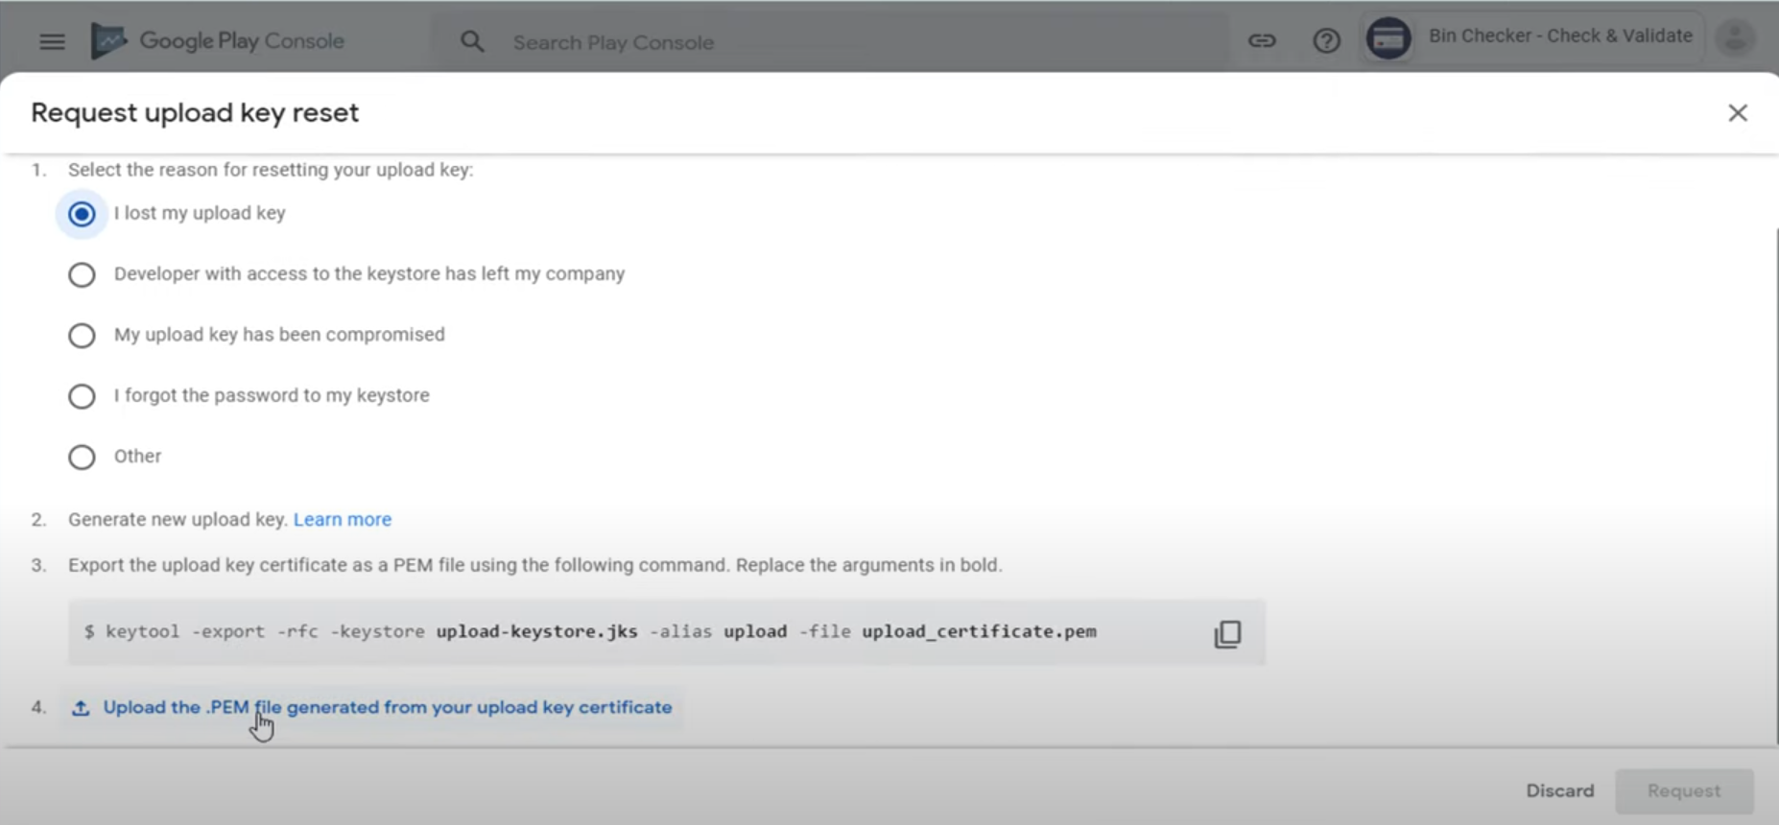

1. Download the **PEM** file which is already uploaded in the **US-551586** in the attachments section “**bcblsa_upload**”.
2. Upload the bcbsla_upload file.
3. Click on the **Request** button.

